CHAPTER 12

TEACHING NOTES

Most of this chapter deals with serial correlation, but it also explicitly considers heteroskedasticity in time series regressions. The first section allows a review of what assumptions were needed to obtain both finite sample and asymptotic results. Just as with heteroskedasticity, serial correlation itself does not invalidate R-squared. In fact, if the data are stationary and weakly dependent, R-squared and adjusted R-squared consistently estimate the population R-squared (which is well-defined under stationarity).

Equation (12.4) is useful for explaining why the usual OLS standard errors are not generally valid with AR(1) serial correlation. It also provides a good starting point for discussing serial correlation-robust standard errors in Section 12.5. The subsection on serial correlation with lagged dependent variables is included to debunk the myth that OLS is always inconsistent with lagged dependent variables and serial correlation. I do not teach it to undergraduates, but I do to master’s students.

Section 12.2 is somewhat untraditional in that it begins with an asymptotic t test for AR(1) serial correlation (under strict exogeneity of the regressors). It may seem heretical not to give the Durbin-Watson statistic its usual prominence, but I do believe the DW test is less useful than the t test. With nonstrictly exogenous regressors I cover only the regression form of Durbin’s test, as the h statistic is asymptotically equivalent and not always computable.

Section 12.3, on GLS and FGLS estimation, is fairly standard, although I try to show how comparing OLS estimates and FGLS estimates is not so straightforward. Unfortunately, at the beginning level (and even beyond), it is difficult to choose a course of action when they are very different.

I do not usually cover Section 12.5 in a first-semester course, but, because some econometrics packages routinely compute fully robust standard errors, students can be pointed to Section 12.5 if they need to learn something about what the corrections do. I do cover Section 12.5 for a master’s level course in applied econometrics (after the first-semester course).

I also do not cover Section 12.6 in class; again, this is more to serve as a reference for more advanced students, particularly those with interests in finance. One important point is that ARCH is heteroskedasticity and not serial correlation, something that is confusing in many texts. If a model contains no serial correlation, the usual heteroskedasticity-robust statistics are valid. I have a brief subsection on correcting for a known form of heteroskedasticity and AR(1) errors in models with strictly exogenous regressors.

SOLUTIONS TO PROBLEMS

12.1 We can reason this from equation (12.4) because the usual OLS standard error is an estimate of 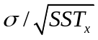. When the dependent and independent variables are in level (or log) form, the AR(1) parameter, ρ, tends to be positive in time series regression models. Further, the independent variables tend to be positive correlated, so (x_{t} − )(x_{t+j} − ) – which is what generally appears in (12.4) when the {x_{t}} do not have zero sample average – tends to be positive for most t and j. With multiple explanatory variables the formulas are more complicated but have similar features.
If ρ < 0, or if the {x_{t}} is negatively autocorrelated, the second term in the last line of (12.4) could be negative, in which case the true standard deviation of 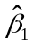 is actually less than .

12.2 This statement implies that we are still using OLS to estimate the β_{j}. But we are not using OLS; we are using feasible GLS (without or with the equation for the first time period). In other words, neither the Cochrane-Orcutt nor the Prais-Winsten estimators are the OLS estimators (and they usually differ from each other).

12.3 (i) Because U.S. presidential elections occur only every four years, it seems reasonable to think the unobserved shocks – that is, elements in u_{t} – in one election have pretty much dissipated four years later. This would imply that {u_{t}} is roughly serially uncorrelated.

(ii) The t statistic for H₀: ρ = 0 is −.068/.240 ≈ −.28, which is very small. Further, the estimate 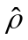 = −.068 is small in a practical sense, too. There is no reason to worry about serial correlation in this example.

(iii) Because the test based on 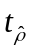 is only justified asymptotically, we would generally be concerned about using the usual critical values with n = 20 in the original regression. But any kind of adjustment, either to obtain valid standard errors for OLS as in Section 12.5 or a feasible GLS procedure as in Section 12.3, relies on large sample sizes, too. (Remember, FGLS is not even unbiased, whereas OLS is under TS.1 through TS.3.) Most importantly, the estimate of ρ is practically small, too. With so close to zero, FGLS or adjusting the standard errors would yield similar results to OLS with the usual standard errors.

12.4 This is false, and a source of confusion in several textbooks. (ARCH is often discussed as a way in which the errors can be serially correlated.) As we discussed in Example 12.9, the errors in the equation return_{t} = β₀ + β₁return_{t-1} + u_{t} are serially uncorrelated, but there is strong evidence of ARCH; see equation (12.51).

12.5 (i) There is substantial serial correlation in the errors of the equation, and the OLS standard errors almost certainly underestimate the true standard deviation in 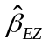. This makes the usual confidence interval for β_{EZ} and t statistics invalid.

(ii) We can use the method in Section 12.5 to obtain an approximately valid standard error. [See equation (12.43).] While we might use g = 2 in equation (12.42), with monthly data we might want to try a somewhat longer lag, maybe even up to g = 12.

12.6 With the strong heteroskedasticity in the errors it is not too surprising that the robust standard error for differs from the OLS standard error by a substantial amount: the robust standard error is almost 82% larger. Naturally, this reduces the t statistic. The robust t statistic is .059/.069 .86, which is even less significant than before. Therefore, we conclude that, once heteroskedasticity is accounted for, there is very little evidence that return_{t-1} is useful for predicting return_{t}.

SOLUTIONS TO COMPUTER EXERCISES

C12.1 Regressing 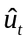 on 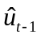, using the 69 available observations, gives .292 and se() .118. The t statistic is about 2.47, and so there is significant evidence of positive AR(1) serial correlation in the errors (even though the variables have been differenced). This means we should view the standard errors reported in equation (11.27) with some suspicion.

C12.2 (i) After estimating the FDL model by OLS, we obtain the residuals and run the regression on , using 272 observations. We get .503 and 9.60, which is very strong evidence of positive AR(1) correlation.

(ii) When we estimate the model by iterated C-O, the LRP is estimated to be about 1.110.

(iii) We use the same trick as in Problem 11.5, except now we estimate the equation by iterated C-O. In particular, write

gprice_{t} = α₀ + θ₀gwage_{t} + δ₁(gwage_{t-1} – gwage_{t}) + δ₂(gwage_{t-2} – gwage_{t})
+ + δ₁₂(gwage_{t-12} – gwage_{t}) + u_{t},

Where θ₀ is the LRP and {u_{t}} is assumed to follow an AR(1) process. Estimating this equation by C-O gives 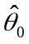 1.110 and se() .191. The t statistic for testing H₀: θ₀ = 1 is (1.110 – 1)/.191 .58, which is not close to being significant at the 5% level. So the LRP is not statistically different from one.

C12.3 (i) The test for AR(1) serial correlation gives (with 35 observations) –.110, se() .175. The t statistic is well below one in absolute value, so there is no evidence of serial correlation in the accelerator model. If we view the test of serial correlation as a test of dynamic misspecification, it reveals no dynamic misspecification in the accelerator model.

(ii) It is worth emphasizing that, if there is little evidence of AR(1) serial correlation, there is no need to use feasible GLS (Cochrane-Orcutt or Prais-Winsten).

C12.4 (i) After obtaining the residuals from equation (11.16) and then estimating (12.48), we can compute the fitted values 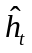 = 4.66 – 1.104 return_{t} for each t. This is easily done in a single command using most software packages. It turns out that 12 of 689 fitted values are negative. Among other things, this means we cannot directly apply weighted least squares using the heteroskedasticity function in (12.48).

(ii) When we add 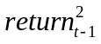 to the equation we get

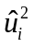 = 3.26 − .789 return_{t-1} + .297 + residual_{t}
(0.44) (.196) (.036)
n = 689, R² = .130.

The conditional variance is a quadratic in return_{t-1}, in this case a U-shape that bottoms out at .789/[2(.297)] 1.33. Now, there are no estimated variances less than zero.

(iii) Given our finding in part (ii) we can use WLS with the obtained from the quadratic heteroskedasticity function. When we apply WLS to equation (12.47) we obtain 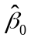 .155 (se .078) and .039 (se .046). So the coefficient on return_{t-1}, once weighted least squares has been used, is even less significant (t statistic .85) than when we used OLS.

(iv) To obtain the WLS using an ARCH variance function we first estimate the equation in (12.51) and obtain the fitted values, . The WLS estimates are now .159 (se .076) and .024 (se .047). The coefficient and t statistic are even smaller. Therefore, once we account for heteroskedasticity via one of the WLS methods, there is virtually no evidence that E(return_{t}|return_{t-1}) depends linearly on return_{t-1}.

C12.5 (i) Using the data only through 1992 gives

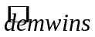 = .441 − .473 partyWH + .479 incum + .059 partyWHgnews
(.107) (.354) (.205) (.036)
− .024 partyWHinf
(.028)
n = 20, R² = .437, 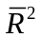 = .287.

The largest t statistic is on incum, which is estimated to have a large effect on the probability of winning. But we must be careful here. incum is equal to 1 if a Democratic incumbent is running and –1 if a Republican incumbent is running. Similarly, partyWH is equal to 1 if a Democrat is currently in the White House and –1 if a Republican is currently in the White House. So, for an incumbent Democrat running, we must add the coefficients on partyWH and incum together, and this nets out to about zero.
The economic variables are less statistically significant than in equation (10.23). The gnews interaction has a t statistic of about 1.64, which is significant at the 10% level against a one-sided alternative. (Since the dependent variable is binary, this is a case where we must appeal to asymptotics. Unfortunately, we have only 20 observations.) The inflation variable has the expected sign but is not statistically significant.

(ii) There are two fitted values less than zero, and two fitted values greater than one.

(iii) Out of the 10 elections with demwins = 1, 8 of these are correctly predicted. Out of the 10 elections with demwins = 0, 7 are correctly predicted. So 15 out of 20 elections through 1992 are correctly predicted. (But, remember, we used data from these years to obtain the estimated equation.)

(iv) The explanatory variables are partyWH = 1, incum = 1, gnews = 3, and inf = 3.019. Therefore, for 1996,

= .441 − .473 + .479 + .059(3) − .024(3.019) .552.

Because this is above .5, we would have predicted that Clinton would win the 1996 election, as he did.

(v) The regression of on produces -.164 with heteroskedasticity-robust standard error of about .195. (Because the LPM contains heteroskedasticity, testing for AR(1) serial correlation in an LPM generally requires a heteroskedasticity-robust test.) Therefore, there is little evidence of serial correlation in the errors. (And, if anything, it is negative.)

(vi) The heteroskedasticity-robust standard errors are given in [] below the usual standard errors:

= .441 − .473 partyWH + .479 incum + .059 partyWHgnews
(.107) (.354) (.205) (.036)
[.086] [.301] [.185] [.030]
– .024 partyWHinf
(.028)
[.019]
n = 20, R² = .437, = .287.

In fact, all heteroskedasticity-robust standard errors are less than the usual OLS standard errors, making each variable more significant. For example, the t statistic on partyWHgnews becomes about 1.97, which is notably above 1.64. But we must remember that the standard errors in the LPM have only asymptotic justification. With only 20 observations it is not clear we should prefer the heteroskedasticity-robust standard errors to the usual ones.

C12.6 (i) The regression on (with 35 observations) gives −.089 and se() .178; there is no evidence of AR(1) serial correlation in this equation, even though it is a static model in the growth rates.

(ii) We regress gc_{t} on gc_{t-1} and obtain the residuals . Then, we regress 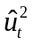 on gc_{t-1} and 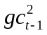(using 35 observations), the F statistic (with 2 and 32 df) is about 1.08. The p-value is about .352, and so there is little evidence of heteroskedasticity in the AR(1) model for gc_{t}. This means that we need not modify our test of the PIH by correcting somehow for heteroskedasticity.

C12.7 (i) The iterated Prais-Winsten estimates are given below. The estimate of ρ is, to three decimal places, .293, which is the same as the estimate used in the final iteration of Cochrane-Orcutt:

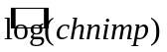 = −37.08 + 2.94 log(chempi) + 1.05 log(gas) + 1.13 log(rtwex)
(22.78) (.63) (.98) (.51)

- .016 befile6 − .033 affile6 − .577 afdec6
(.319) (.322) (.342)

n = 131, R² = .202

(ii) Not surprisingly, the C-O and P-W estimates are quite similar. To three decimal places, they use the same value of 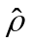 (to four decimal places it is .2934 for C-O and .2932 for P-W). The only practical difference is that P-W uses the equation for t = 1. With n = 131, we hope this makes little difference.

C12.8 (i) This is the model that was estimated in part (vi) of Computer Exercise C10.11. After getting the OLS residuals, , we run the regression 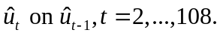 (Included an intercept, but that is unimportant.) The coefficient on is 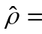.281 (se = .094). Thus, there is evidence of some positive serial correlation in the errors (t ≈ 2.99). I strong case can be made that all explanatory variables are strictly exogenous. Certainly there is no concern about the time trend, the seasonal dummy variables, or wkends, as these are determined by the calendar. It is seems safe to assume that unexplained changes in prcfat today do not cause future changes in the state-wide unemployment rate. Also, over this period, the policy changes were permanent once they occurred, so strict exogeneity seems reasonable for spdlaw and beltlaw. (Given legislative lags, it seems unlikely that the dates the policies went into effect had anything to do with recent, unexplained changes in prcfat.

(ii) Remember, we are still estimating the β_{j} by OLS, but we are computing different standard errors that have some robustness to serial correlation. Using Stata 7.0, I get 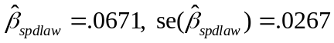 and 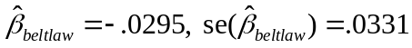. The t statistic for spdlaw has fallen to about 2.5, but it is still significant. Now, the t statistic on beltlaw is less than one in absolute value, so there is little evidence that beltlaw had an effect on prcfat.

(iii) For brevity, I do not report the time trend and monthly dummies. The final estimate of ρ is 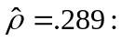

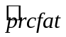 = 1.009 + … + .00062 wkends − .0132 unem
(.102) (.00500) (.0055)

+ .0641 spdlaw − .0248 beltlaw
(.0268) (.0301)

n = 108, R² = .641

There are no drastic changes. Both policy variable coefficients get closer to zero, and the standard errors are bigger than the incorrect OLS standard errors [and, coincidentally, pretty close to the Newey-West standard errors for OLS from part (ii)]. So the basic conclusion is the same: the increase in the speed limit appeared to increase prcfat, but the seat belt law, while it is estimated to decrease prcfat, does not have a statistically significant effect.

C12.9 (i) Here are the OLS regression results:

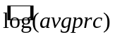 = −.073 − .0040 t − .0101 mon − .0088 tues + .0376 wed + .0906 thurs
(.115) (.0014) (.1294) (.1273) (.1257) (.1257)

n = 97, R² = .086

The test for joint significance of the day-of-the-week dummies is F = .23, which gives p-value = .92. So there is no evidence that the average price of fish varies systematically within a week.

(ii) The equation is

= −.920 − .0012 t − .0182 mon − .0085 tues + .0500 wed + .1225 thurs
(.190) (.0014) (.1141) (.1121) (.1117) (.1110)

+ .0909 wave2 + .0474 wave3
(.0218) (.0208)

n = 97, R² = .310

Each of the wave variables is statistically significant, with wave2 being the most important. Rough seas (as measured by high waves) would reduce the supply of fish (shift the supply curve back), and this would result in a price increase. One might argue that bad weather reduces the demand for fish at a market, too, but that would reduce price. If there are demand effects captured by the wave variables, they are being swamped by the supply effects.

(iii) The time trend coefficient becomes much smaller and statistically insignificant. We can use the omitted variable bias table from Chapter 3, Table 3.2 to determine what is probably going on. Without wave2 and wave3, the coefficient on t seems to have a downward bias. Since we know the coefficients on wave2 and wave3 are positive, this means the wave variables are negatively correlated with t. In other words, the seas were rougher, on average, at the beginning of the sample period. (You can confirm this by regressing wave2 on t and wave3 on t.)

(iv) The time trend and daily dummies are clearly strictly exogenous, as they are just functions of time and the calendar. Further, the height of the waves is not influenced by past unexpected changes in log(avgprc).

(v) We simply regress the OLS residuals on one lag, getting 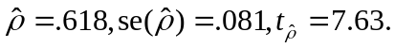 Therefore, there is strong evidence of positive serial correlation.

(vi) The Newey-West standard errors are 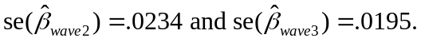 Given the significant amount of AR(1) serial correlation in part (v), it is somewhat surprising that these standard errors are not much larger compared with the usual, incorrect standard errors. In fact, the Newey-West standard error for 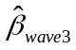is actually smaller than the OLS standard error.

(vii) The Prais-Winsten estimates are

= −.658 − .0007 t + .0099 mon + .0025 tues + .0624 wed + .1174 thurs
(.239) (.0029) (.0652) (.0744) (.0746) (.0621)

+ .0497 wave2 + .0323 wave3
(.0174) (.0174)

n = 97, R² = .135

The coefficient on wave2 drops by a nontrivial amount, but it still has a t statistic of almost 3. The coefficient on wave3 drops by a relatively smaller amount, but its t statistic (1.86) is borderline significant. The final estimate of ρ is about .687.

C12.10 (i) OLS estimation using all of the data gives

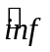 = 1.05 + .502 unem
(1.55) (.266)

n = 56, R² = .062, = .045.

(ii) I included an intercept and got = .572 with t = 5.28, which is very strong evidence of positive serial correlation.

(iii) The iterative Prais-Winsten estimates are

= 8.00 − .714 unem
(2.05) (.290)

n = 56, R² = .135, = .119.

The slope estimate, −.714, is almost identical to that using the data through 1996, −.716. (Adding more data has reduced the standard error.)

(iv) The iterative C-O estimates are

= 7.28 − .663 unem
(2.16) (.294)

n = 55, R² = .088, = .070,

and the final estimate ofis .782. The final estimate of for PW is .789, which is very close to the C-O estimate. The slope coefficients differ by more than we might expect: −.663 for CO and −.714 for PW. Using the first observation has a some effect, although the estimates give the same basic story.

C12.11 (i) The average of over the sample is 4.44, with the smallest value being .0000074 and the largest being 232.89.

(ii) This is the same as C12.4, part (ii):

= 3.26 − .789 return_{t-1} + .297 + residual_{t}
(0.44) (.196) (.036)
n = 689, R² = .130.

(iii) The graph of the estimated variance function is

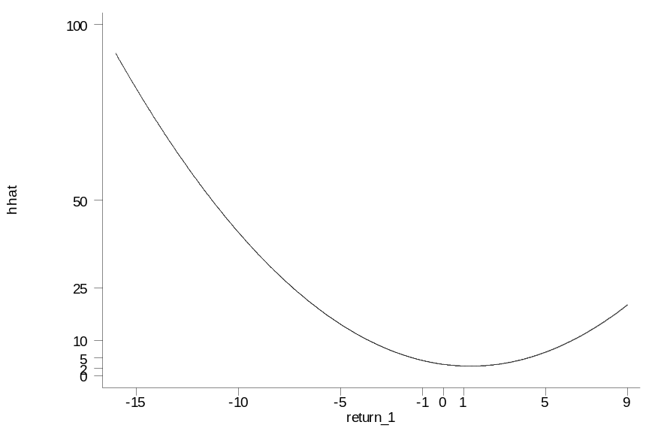

The variance is smallest when return₋₁ is about 1.33, and the variance is then about 2.74.

(iv) No. The graph in part (iii) makes this clear, as does finding that the smallest variance estimate is 2.74.

(v) The R-squared for the ARCH(1) model is .114, compared with .130 for the quadratic in return₋₁. We should really compare adjusted R-squareds, because the ARCH(1) model contains only two total parameters. For the ARCH(1) model, is about .112; for the model in part (ii), = .128. Therefore, after adjusting for the different df, the quadratic in return₋₁ fits better than the ARCH(1) model.

(vi) The coefficient on 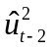 is only .042, and its t statistic is barely above one (t = 1.09). Therefore, an ARCH(2) model does not seem warranted. The adjusted R-squared is about .113, so the ARCH(2) fits worse than the model estimated in part (ii).

C12.12 (i) The regression for AR(1) serial correlation gives = −.110 with t = −.63. The estimate of rho is small and statistically insignificant, so AR(1) serial correlation does not appear to be a problem (as is often the case for regressions using differenced data).

(ii) The OLS and PW estimates of 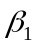 are .152, rounded to three digits. Given that part (i) indicated little problem of serial correlation, we hope that they would be very similar.

